**A MULTIPLATFORM H.R.I.S WITH TAG-MATCHING AI FOR GAMMACARE MEDICAL SERVICES INCORPORATION**

**A Capstone Project Proposal Presented to the Faculty of the**

**Information and Communications Technology Program STI College San Jose Del Monte Bulacan**

**In Partial Fulfilment**

**of the Requirements for the Degree Bachelor of Science in Information Technology**

**Kynth Anthony P. Marcaida Ezekiel B. Pilar**

**Juan Miguel A. Rosas Jameer Ken S. Verano**

**June 2024**

**ENDORSEMENT FORM FOR PROPOSAL DEFENSE**

**TITLE OF RESEARCH: A MULTIPLATFORM H.R.I.S WITH**

**TAG-MATCHING AI FOR GAMMACARE MEDICAL SERVICES INCORPORATION**

**NAME OF PROPONENTS:** Kynth Anthony P. Marcaida

Ezekiel B. Pilar

Juan Miguel A. Rosas Jameer Ken S. Verano

In Partial Fulfilment of the Requirements

for the degree Bachelor of Science in Information Technology has been examined and is recommended for Oral Defense.

## ENDORSED BY:

John Carlo D. Silmaro

**Capstone Project Adviser**

## APPROVED FOR PROPOSAL DEFENSE:

Chris Jonel B. Barrameda

**Capstone Project Coordinator**

## NOTED BY:

Edmond O. Castillo

**Program Head**

## APPROVAL SHEET

This capstone project proposal titled: **A Multiplatform H.R.I.S with Tag-Matching AI for Gammacare Medical Services Incorporation** prepared and submitted by **Kynth Anthony P. Marcaida, Jameer Ken S. Verano, Juan Miguel A. Rosas**, and **Ezekiel B. Pilar**, in partial fulfillment of the requirements for the degree of Bachelor of Science in Information Technology, has been examined and is recommended for acceptance and approval.

### John Carlo D. Silmaro

Capstone Project Adviser

Accepted and approved by the Capstone Project Review Panel in partial fulfillment of the requirements for the degree of Bachelor of Science in Information Technology

|  |  |
| --- | --- |
| Jayne C. Isip | Jan Joshua D. Mangahas |
| **Panel Member** | **Panel Member** |

Enoch James C. Tayanguna

**Lead Panelist**

**Noted:**

|  |  |
| --- | --- |
| Chris Jonel B. Barrameda | Edmond O. Castillo |
| **Capstone Project Coordinator** | **Program Head** |

## TABLE OF CONTENTS

|  |  |
| --- | --- |
|  | **Page** |
| **Title Page** | **i** |
| **Endorsement form for Proposal Defense** | **ii** |
| **Approval Sheet** | **iii** |
| **Table of Contents** | **iv** |
| **Introduction** | **1** |
| **Project Context** | **1** |
| **Purpose and Description** | **3** |
| **Objectives** | **4** |
| **Scope and Limitations** | **5** |
| **Review of Related Literature/Systems** | **11** |
| **Related Literature** | **11** |
| **Related Studies and/or Systems**  **Synthesis** | **15**  **19** |
| **Technical Background** | **20** |
| **Overview of Current Technologies to be Used in the System** | **20** |
| **Calendar of Activities** | **22** |
| **Resources** | **25** |
| **Methodology, Results, and Discussion** | **26** |
| **Requirements Analysis** | **29** |
| **Requirements Documentation** | **30** |
| **Design of Software, System, Product, and/or Processes** | **33** |
| **References** | **41** |
| **Appendices** | **43** |
| **Resource Persons** | **44** |
| **Personal Technical Vitae** | **46** |

**INTRODUCTION**

### Project Context

Human Resources departments play a crucial role in any organization, handling various tasks such as managing employee data, processing payroll, administering benefits, and conducting performance evaluations. Without a Human Resource Information System (HRIS), these tasks are often performed manually, leading to extensive paperwork, reliance on spreadsheets, and manual communication methods. This manual approach can result in inefficiencies, errors, and delays, making effective workforce management challenging.

Gammacare Medical Services Inc., committed to providing exceptional healthcare solutions, is embracing modern technology with the introduction of an HRIS. Since its establishment, Gammacare has been dedicated to revolutionizing healthcare services through innovation and efficiency.

In an interview, Gammacare disclosed that managing its workforce efficiently has become challenging due to the limitations of its current HR processes. As a small to medium-sized business, Gammacare does not have a system for managing HR tasks. Tracking the expiration of employee contracts requires manual input into physical calendars, with reminders needed three months in advance. If contracts are not renewed on time, it can lead to legal issues, as employees may sue the company if there are any disputes. Filing a leave request involves entering data into an Excel sheet, indicating whether the leave is paid or unpaid. Employees are entitled to 15 days of leave per year, which do not carry over to the next year if unused. This manual process is inefficient and prone to errors. Updating employee details requires handling a large volume of paperwork stored in filing cabinets, including documents for applicants who have not yet attended interviews but whose information cannot be discarded.

A HRIS is a software solution designed to modernize and automate various human resource management tasks within an organization. It serves as a centralized database for managing employee information, facilitating processes such as attendance tracking, payroll management, benefits administration, and performance evaluation. By leveraging modern technology, an HRIS aims to replace manual and paper-based HR processes with digital solutions, thereby improving efficiency, accuracy, and overall productivity.

The extensive paperwork involved in managing HR processes poses a considerable challenge. Locating specific documents in filing cabinets is cumbersome and time- consuming. Reminding employees of training certificate expirations and contract renewals is difficult due to the overwhelming amount of paperwork. Moreover, discrepancies between the HR and accounting departments arise when employee resignations are not promptly updated, leading to communication issues and inefficiencies.

To address these challenges, Gammacare has proposed implementing a web-based HRIS with Artificial Intelligence (AI). This advanced system will facilitate efficient management of employee information, attendance tracking, and payroll processing. A key feature of the new HRIS is the AI document generator, which will significantly reduce the burden of extensive paperwork. By enabling HR personnel to create documents such as offer letters, contracts, and policy documents through AI prompts, this feature eliminates the need for manual input and improves efficiency. This automation will save time and reduce the likelihood of errors and inconsistencies associated with manual document creation.

Overall, the implementation of a multi-platform web-based HRIS is assured to address the current HR-related challenges faced by Gammacare Medical Services Inc. By embracing modern technology, Gammacare aims to enhance operational efficiency, improve employee satisfaction, and maintain its commitment to excellence in healthcare services.

### Purpose and Description

This project's purpose is to implement a modern Human Resource Information System (HRIS) for Gammacare Medical Services Incorporation. Human Resource Information System (HRIS) is designed to improve the way the organization manages its human resources by using technology to make processes faster, more accurate, and more efficient. This system will centralize all employee information and simplify manual tasks.

The new system will feature a user-friendly interface, a complete employee database, and an Artificial Intelligence (AI) tool that automatically produces Human Resource (HR) documents such as offer letters, contracts, and policy documents through Artificial Intelligence (AI) prompts, eliminating manual input and enhancing efficiency while reducing errors and inconsistencies. Additionally, documents can be downloaded as Portable Document Format (PDF) files for easy sharing and storage.

The project will start by thoroughly examining Gammacare’s current Human Resource (HR) processes and needs. Following this analysis, the Human Resource Information System (HRIS) will be designed and developed to boost productivity, centralize employee data, automate Human Resource tasks, ensure accurate reporting, and simplify onboarding.

By collecting feedback from human resource professionals, employees, and organizational leaders, the project will assess the impact and effectiveness of the new system. This feedback will be used to develop recommendations for the best ways to implement, use, and optimize the Human Resource Information System (HRIS) at Gammacare.

In summary, this project aims to provide Gammacare Medical Services Incorporation with a modern Human Resource Information System (HRIS) that will solve current Human Resource (HR) challenges, increase operational efficiency, and support the organization's commitment to delivering excellent healthcare services.

### Objectives

* **To design and develop an information system that will expedite manual Human Resource (HR).**

This system will handle tasks such as monitoring employee contract expirations, approving leave requests, managing employee information, and facilitating processes like attendance tracking, payroll management, and benefits administration.

### To design and develop a centralized employee database containing all employee data into a safe, accessible system.

Creating a local database containing all employee data, that is accessible for managing employee information including personal details, employment history, and performance records.

### To design and develop a Human Resource Information System (HRIS) that caters to the needs and preferences of users.

Designing a user-friendly Human Resource Information System (HRIS) that will have all the things HR managers and employees need, like tracking leave and managing employee data.

### To design and develop a Human Resource Information (HRIS) system to expedite the process of managing paperwork-intensive documentation.

Developing a Human Resource Information System (HRIS) to simplify the burden of paperwork, improving the speed, accuracy, and efficiency of HR procedures. This system is designed to support HR staff in cutting down on repetitive letter writing tasks.

### Scope

**Super Admin Module Login**

Includes fields for entering a username and password.

### Account Management

* + **Create, Manage User Accounts, and Assign Roles**

Super Administrators can create new user accounts by entering the employee's name, contact number, email address, and password. Once entered, the system sends an email to the employee's email address with their user account information, including the password. Additionally, Super Administrators can grant or revoke roles and remove employees below their hierarchy level. The removed employee accounts will be stored in an archive.

### Human Resource Manager Module Login

Includes fields for entering a username and password. If they forgot their password, there will be an option “Forgot password?”.

### Dashboard

* + **Employee Tracking**

Includes total headcount and daily attendance records. Tracks present employees, late arrivals, and those on leave.

### Calendar View

Displays scheduled events.

### Turnover Rates

Monthly turnover rates are shown, highlighting both voluntary and involuntary departures. Provides insights into workforce stability.

### Employment Status

Categorizes employees into student, part-time, and full-time. Offers a clear legend for easy reference.

### Real-time Notifications

Alerts administrators to employee time-in and time-outs.

### Profile

Can view their credentials such personal information and contracts.

### Recruitment Management

* + **Open Positions**

Maintain a database of current job openings and associated details.

### Applicant List

Maintain a comprehensive list of all applicants for each open position, tracking their contact information, application status, and interview schedules.

### AI Tag Matching Resume

Utilize artificial intelligence algorithms to match candidate resumes with job qualifications.

### Proficiency Test

The proficiency test will be conducted by the Human Resource Manager, which will furnish the test questions along with their corresponding answer key. The AI will rephrase and arrange the questions as needed. Upon completion, the accuracy rate of employee responses will be presented.

### Document Template

Includes predefined templates that allow for reuse by entering necessary personal information such as name, age, contact details, and job title

### Onboarding

* + **Recruitment probationary**

View the details of probationary employees and update whether they are hired or not.

### Learning Programs

Provide comprehensive learning and training programs for new hires during onboarding, along with ongoing seminars for current employees to ensure continuous professional development.

### Employee Management

* + **Employee Info**

Store employee details, including personal information, employment history, and job roles, in a structured format.

### Employee Contracts

Track employee contract expiration dates and automate reminders for HR personnel. Additionally, it will provide notifications to HR staff three months before a contract expires to ensure timely renewal and prevent legal issues.

### Employee Shift Schedule

Can view and edit the employee's shift schedule.

### Create and Manage User Accounts and Assign Roles

Human Resource Manager (HRM) can create new user accounts by entering the employee's name, contact number, email address, and password. Once entered, the system sends an email to the employee's email address with their login information, including the password. Additionally, Human Resource Manager (HRM) can grant or revoke roles and remove employees below their hierarchy level. The removed employee account will be stored in an archive.

### Attendance

* + **Biometric attendance monitoring**

Recording employees' time-in time-out using RFID card.

### Accumulation of Total Work Hours

Calculate and accumulate total work hours for each employee.

### Leave Request Management

Human resource managers will have the authority to accept or deny leave requests and will maintain visibility of all submitted requests and keep a record of employees' leave history for reference and tracking purposes.

### Payroll

* + **Payroll Form**

The payroll details include the employee's id, name, pay per hour, total hours worked, and gross pay. Additionally, input is required for income tax and other deductions to calculate the net pay total.

### Salary History

Includes the past earnings or salary details of all employees

### Employee Module Login

Includes fields for entering a username and password. If they forgot their password, there will be an option “Forgot password?”.

### Dashboard

Employees can access a centralized platform to view their assigned work hours, shift details, and an overview of the work log.

### Profile

Can view their credentials such personal information and contracts.

### Shift Schedule

Employees can view their complete shift schedule.

### Leave Management

* + **Leave Request**

AI can generate leave letters based on input such as the start and end dates of leave, along with the type of leave. Additional context is required for a more specific and informative leave letter. Users also can attach files if they have already created them outside of the system.

### View Leave Balances and History

Employees can check their remaining leave balances and view a record of past leave taken.

**View Salary History**

Employees can access a record of their past salary. To access the information, it will require a two-factor authenticator through One-Time Password (OTP) code sent via SMS.

### Limitations

**Online Transaction**

Lack of capability to handle online transactions such as G-Cash, PayPal, BDO.

### Integration with Other Systems

Lack of capability to integrate with essential enterprise systems such as accounting software, ERP systems, Benefit systems. It means that data synchronization and automated workflows between these systems will not be possible.

## REVIEW OF RELATED LITERATURE/SYSTEMS

### Foreign Literature

According to Panjaitan et al. (2023) the critical importance of implementing Human Resource Information System (HRIS) in modern organizations is to enhance the efficiency and effectiveness of HRM practices. By leveraging HRIS, companies can streamline HR processes, improve data accuracy, and optimize resource allocation. The authors identify several challenges faced by companies in manual HRM processes, including issues with employee discipline, policy determination, sudden shift changes, income inconsistencies and subjective performance appraisals. These challenges highlight the complexity of managing human resources and the limitations of traditional methods in addressing them effectively. Therefore, the study aims to explore how the implementation of HRIS can mitigate these critical problems and drive overall organizational performance in HRM towards success. By adopting HRIS, companies can not only streamline operations but also enhance decision-making, data management, and employee engagement, ultimately leading to improved organizational outcomes and competitive advantage in the market.

According to Udekwe et al. (November 2021) Utilization of Human Resource Information System (HRIS) within healthcare sector of South Africa. The study comprehensively explores the implementation and impact of HRIS in this context, modernizing current practices, challenges, and opportunities for improvement. Notably, the findings highlight the significance of Resource Information System (HRIS) in augmenting Human Resource (HR) management processes, enhancing decision-making capabilities, and increasing the efficiency and effectiveness of healthcare operations. These strategies include advocating for customized system designs tailored to the specific needs of healthcare organizations, with basic user training programs, fostering organizational support for HRIS implementation initiatives. Additionally, the study recommends the

integration of HR analytics and the alignment of HR practices with broader organizational objectives to optimize the benefits derived from HRIS deployment.

According to Quaosar et al. (2021), they emphasize that traditional HR management systems are increasingly insufficient in meeting demands of modern organizations, it requires the implementation of integrated IS, particularly HRIS, to improve productivity, service quality, employee management, and strategic decision-making. However, the authors identify several barriers to effective HRIS implementation, including high conversion costs, insufficient training for employees, lack of infrastructure and technical knowledge and insufficient funding. Despite these challenges, the study underscores the importance of HRIS in optimizing HR functions such as recruitment, training, payroll, administration, benefits management, performance appraisal, and Human Resource (HR) planning. The study contributes both theoretically and practically by providing insights into the benefits and barriers of Human Resource Information System (HRIS) adoption, emphasizing the need for a comprehensive strategy to Human Resource Information System (HRIS) management and decision-making. The study underscores the critical role of HRIS in enhancing organizational effectiveness and highlights the need for further research to address the challenges hindering its successful implementation.

### Local Literature

According to Caparas et al., (2023), implementing HRIS for Yngen Datacom Corporation plays a crucial role in modern organizations by streamlining HR processes, managing employee data, and enhancing overall efficiency. Without the implementation of HRIS according to their research, it causes inefficient data management wherein organizations may rely on manual processes for managing employee data leading to errors, duplication of efforts and time-consuming administrative tasks. Limited Reporting and Analysis without HRIS may struggle to generate comprehensive reports and analyze HR metrics effectively, hindering strategic decision-making and workforce planning. There is also the compliance risk that Yngen Datacom corporation find it challenging to stay compliant with labor laws, regulations, and industry standards. Lack of HRIS affects the HR department’s effectiveness in recruitment and onboarding in which the organization struggles with manual recruitment tasks and onboarding procedures.

HRIS provides valuable insights and analytics that enable HR professionals to make data-driven decisions and align HR strategies with organizational goals. Without HRIS, HR departments may lack the tools needed for strategic HR management. In conclusion, the absence of HRIS in Yngen Datacom Corporation can lead to inefficiencies, data security risks, compliance challenges, reduced employee engagement, recruitment difficulties, and limitations in strategic HR management. Implementing an effective HRIS can address these problems and empower organizations to optimize their HR processes, enhance employee satisfaction, and drive overall organizational success.

MBHTE deals with 60 percent of the number of Bangsamoro Autonomous Region in Muslim Mindanao **(**BARMM) employees and requires strategic direction so that desired changes will be attained. Addressing identified issues and concerns will enable the ministry to accomplish its tasks effectively and efficiently. Recently, the Ministry developed and piloted HRIS to improve the reporting and monitoring of government employees through automation. The main function of these features

in the dashboard application is to provide automated reports of HR Management, Performance Evaluation, Document/Files, Data Parameter, and User Management. The study identified several problems associated with the use of HR manual system, including issues with records management, changes detection, validity checking, data accuracy, and data dimensions. These challenges highlighted the inefficiencies and limitations of the manual system in meeting the needs of MBHTE in managing human resources effectively. In conclusion, the research findings indicated a significant difference between the HR manual system and HRIS, with HRIS demonstrating high performance in various aspects such as HR management, performance evaluation, document/files management, data parameter handling, and user management. The study recommended the adoption of HRIS in BARMM government offices, capacity building for HR personnel in utilizing HRIS, promoting a culture of compliance among government employees, and further research on extending HRIS to other sectors. Overall, the study emphasized the importance of HRIS in enhancing operational efficiency and effectiveness within MBHTE and the broader government context. (Salah et al., 2022)

According to Balu et al. (2019) Artificial intelligence of computer science which aims to solve cognitive problems associated with human intelligence and beyond. AI enables machines to “think like humans,” and perform tasks such as leaning, problem solving, reasoning and language processing. These ideas can reveal new ways to increase hiring process success and deepen understanding of the company's employees from a strategic perspective. Combined with expertise in human resource management, this enhanced intelligence will help companies save costs, improve talent quality, and improve the effectiveness of employee team plans. Artificial intelligence with human intelligence enhances candidate experience for many companies the first pilots of artificial intelligence are in talent acquisition, as this is the area where companies see significant, measurable, and immediate results in reducing time to hire, increasing productivity for recruiters, and delivering an enhanced candidate experience that is seamless, simple, and intuitive. According to studies the DBS Talent Acquisition team created JIM (Jobs

Intelligence Maestro), a virtual recruitment bot powered by artificial intelligence used to conduct Following the introduction of JIM in May 2018, DBS talent acquisition was able to shorten the screening time from 32 minutes per candidate to 8 minutes per candidate, improve completion rate of job application from 85% to 97% and respond to 96% of all candidate queries through JIM, allowing recruiters to spend more time sharing the culture and values of DBS with candidates.

### Related Studies and/ or Systems

**Foreign Related Studies and/or System**

* **BambooHR**

BambooHR is a cloud-based HRIS designed to streamline HR processes for small to medium-sized businesses. It offers a user-friendly interface and customizable features to manage employee data, time-off tracking, onboarding, performance management, and more. BambooHR aims to simplify HR tasks, improve efficiency, and enhance employee experience by centralizing all HR-related information in one platform. It helps businesses automate routine HR processes, maintain compliance, and make data-driven decisions. BambooHR provides functionalities such as employee database management, applicant tracking, performance reviews, time tracking, reporting, and document management. It allows HR professionals to create custom workflows, set up notifications, and integrate with other business software for seamless data exchange.

### ADP Workforce Now

Automatic Data Processing (ADP) Workforce Now is a comprehensive Human Resource Information System and payroll solution designed for businesses of all sizes. It offers a suite of tools to manage HR, payroll, time and attendance, benefits administration, talent management, and compliance. ADP Workforce Now aims to simplify HR and payroll processes, reduce administrative burden, and improve accuracy and compliance. It provides scalable solutions tailored to the needs of different industries and helps businesses adapt to changing workforce dynamics. ADP Workforce Now includes features such as employee self-service, HR analytics, tax compliance, workforce scheduling, performance management, and mobile access. It integrates with other business systems, such as accounting software and benefits providers, to streamline data flow and optimize efficiency.

* **Zenefits**

Zenefits is a cloud-based HRIS designed for small to medium-sized businesses. It provides a comprehensive suite of tools to manage HR, payroll, benefits, compliance, and employee onboarding all in one platform. Zenefits aims to simplify HR management by automating administrative tasks, improving compliance, and providing an intuitive user experience. It helps businesses streamline their HR processes, reduce manual errors, and enhance overall efficiency. Zenefits offers features such as employee self- service, time and attendance tracking, benefits administration, payroll processing, performance management, and HR reporting. The platform also includes compliance tools to help businesses adhere to labor laws and regulations.

### Local Related Studies and/or Systems

* **easyHR**

easyHR by Human Incubator Inc is an HRIS designed to simplify HR processes for small and medium-sized enterprises in the Philippines. The software includes features for robust record-keeping, payroll processing, and employee management. It offers a user-friendly interface and integration capabilities with other business systems. The primary purpose of easyHR is to streamline HR tasks and improve operational efficiency for businesses. It provides a comprehensive solution that reduces the administrative workload and enhances the accuracy of HR data management. easyHR offers functionalities such as employee record management, payroll automation, benefits administration, and performance tracking. It also supports compliance with local regulations and generates detailed reports for HR analysis. easyHR was created to meet the growing demand for efficient HR management tools among Philippine SMEs. By providing an affordable and easy-to-use platform, it helps businesses manage their HR processes more effectively and focus on strategic growth.

### Human Resource Information System (HRIS): An Evaluation of Net Benefits Based on the Perception of HR Practitioners by Roma C. Paje (2023)

The study investigated Human Resource Information Systems (HRIS) in the Business Process Outsourcing (BPO) industry in the Philippines to understand how well HRIS works in providing HR services. It wanted to see how different things like system quality, information quality, service quality, use, user satisfaction, and net benefits affect HRIS use. By checking if the DeLone and McLean IS success model fits with HRIS in the BPO industry, the study managed to solve the research problem by showing how

these things connect and influence HRIS success. In the end, the research not only met its goal of studying what affects HRIS performance but also gave useful tips for HRIS users and business owners on how to make HRIS work better in giving quick, good, and effective HR services in the BPO sector.

### Human Resource Information System of the Panpacific University North Philippines (HRIS-PUNP) by Teresa Rabago (December 2019)

This study focuses on developing a network-based HRIS for Panpacific University North Philippines. It details the use of the Systems Development Life Cycle (SDLC) waterfall model to create a robust system for managing HR tasks. Interviews with HR personnel were conducted to gather data on the existing manual processes, ensuring the new system meets all identified needs. This study's purpose is to streamline the HR functions of the university, including employee profiling, benefits management, and labor management. By automating these processes, the system aims to reduce the time and effort required to handle HR tasks. Additionally, it seeks to improve data accuracy and accessibility for HR personnel. The HRIS- PUNP includes features such as employee information management, report generation, and automatic leave computation. It also incorporates robust security measures to protect sensitive data. The system is designed to be deployed in a Local Area Network (LAN) environment, facilitating data sharing among employee workstations. The system was created to replace the manual record-keeping processes currently used by the university’s HR department. This manual system was prone to errors and inefficiencies, which the new HRIS aims to eliminate.

### Synthesis

Implementing Human Resource Information Systems (HRIS) is crucial for streamlining Human Resource processes, enhancing data accuracy, and optimizing resource allocation. Customized systems and Human Resource analytics improve decision-making and operational efficiency. Despite barriers like high costs and insufficient training, Human Resource Information Systems (HRIS) plays a critical role in recruitment, training, payroll, and performance appraisal. Locally, Human Resource Information Systems (HRIS) helps address inefficiencies in manual data management and compliance challenges, leading to improved strategic decision- making. Successful Human Resource Information Systems (HRIS) implementation leads to significant improvements in HRM and performance evaluation, with Artificial Intelligence further enhancing employee experience, especially in leave filing processes.

Based on the studies provided, several key functions can enhance Human Resource Management in the proposed system. Expediting Human Resource tasks reduces errors and improves efficiency. A centralized database streamlines data tracking and retrieval. Integration of data analytics tools provides insights into Human Resource metrics. AI-driven features enhance employee experience. Customizable user interfaces ensure ease of use. Features for compliance and risk management help adhere to labor laws. Providing training and ongoing support ensures effective system utilization. These functions significantly enhance Human Resource Management efficiency, leading to improved organizational performance. The proposed system is named Multiplatform Human Resource Information System with Artificial Intelligence.

## TECHNICAL BACKGROUND

### Overview of Current Technologies to be Used in the System

**Visual Studio Code** is the source code editor used by the proponents. It makes it simple to develop, debug, and modify programs. HTML will be used to structure the web pages of our system, defining the layout and organization of content on the website. CSS is essential for styling these web pages, controlling the visual presentation, including layout, colors, fonts, and responsiveness. JavaScript will be used to add interactivity and dynamic content to the web pages, enabling client-side scripting to create a more engaging user experience. Since Visual Studio Code has a Live Server extension tool that allows it to run webpages, it will be able to run the HTML, CSS, and JavaScript files that the team has produced. The integrated terminal and support for various extensions enhance productivity and streamline the development workflow.

**PHP** is a server-side scripting language used for backend development. It processes data from the frontend and interacts with the database. PHP will handle backend processes such as form submissions, user authentication, data processing, and server-side logic. It integrates seamlessly with MySQL to perform database operations and ensures secure data transactions.

**MySQL** is a relational database management system used to store, retrieve, and manage data efficiently. It will handle all database operations such as CRUD (Create, Read, Update, Delete) functions, ensuring data integrity and security. MySQL's robust querying capabilities will support complex data operations and reporting needs.

**OpenAI** will be used to create a Tag Matching AI, enhancing the system's capability to understand and categorize data intelligently. It will assist in automating tasks such as matching tags to content, improving search functionality, and providing intelligent recommendations. The integration of AI will streamline processes and enhance the user experience through advanced data processing and insights.

**Figma** is a design tool used to design the user interface of our HRIS system. It facilitates collaboration among team members, allowing for real-time collaboration and feedback. Figma ensures a user-friendly and visually appealing layout, streamlining the design process and ensuring consistency across the project.

**Draw.io** is used for creating diagrams and flowcharts, aiding in visualizing the framework of our HRIS system. It will help in planning and documenting the system's structure, processes, and data flows. Using Draw.io ensures clear communication of complex ideas and enhances the team's ability to plan and implement the system effectively.

**Semaphore SMS Application Program Interface (API) –** This serves as an SMS service provider, offering SMS functionality within the system. It is software designed to seamlessly incorporate text messages for user prompts and verifications.

### Calendar of Activities

In February, we worked on preparing 10 capstone project titles. During the first week, we brainstormed and did some initial research to come up with a bunch of ideas. In the second week, we narrowed these down to the best 10 by checking what was feasible and getting feedback from advisors. The third week was spent writing detailed proposals for each title, explaining the background, goals, methods, expected results, and importance of each project. Finally, in the fourth week, we reviewed and revised our proposals based on peer and advisor feedback, making sure everything was clear and well-organized before presenting them.

In the first week of March, we presented our 10 capstone project titles to a panel of evaluators. During the presentations, we explained the project context, purpose and description, objectives, and scope and limitations, aiming to demonstrate their feasibility and relevance. The panelists provided feedback and suggestions for improvement, which were invaluable for refining our proposals. Additionally, we received approval to proceed with our selected title for the HRIS (Human Resource Information System) project, marking a significant step forward in our capstone journey. During the third and fourth weeks of March, we began working on Chapter 1 of our capstone project. This chapter typically includes the project context, purpose and description, objectives, and scope and limitations.

In the first week of April, we successfully completed Chapter 1 of our capstone project, which encompasses the project context, purpose and description, objectives, and scope and limitations. After completing Chapter 1, we consulted with our advisor to review our progress and receive feedback for improvement. Following the consultation, we started working on Chapter 2, which typically covered the review of related literature. During the third and fourth weeks, we met with our advisor to consult our Chapter 2. We sought guidance on the review of related literature.

In the first to fourth weeks, we began working on Chapters 3 and 4 of our project. Chapter 3 focuses on the technical background, explaining the software and

hardware we will use to accomplish our project, while Chapter 4 outlines our methodology, detailing how we plan to conduct our research. During the second and fourth weeks, we met with our advisor to discuss our progress on these chapters, making sure we were heading in the right direction. Additionally, in the fourth week, we held a mock defense to prepare for the final defense.

In the first week of June, we conducted a survey targeting Human Resources professionals. This survey aimed to gather valuable insights and data relevant to our project or research. By reaching out to HR professionals, we sought to understand industry trends, challenges, and preferences, which would help inform our project's direction and findings.

### Gantt Chart of Activities

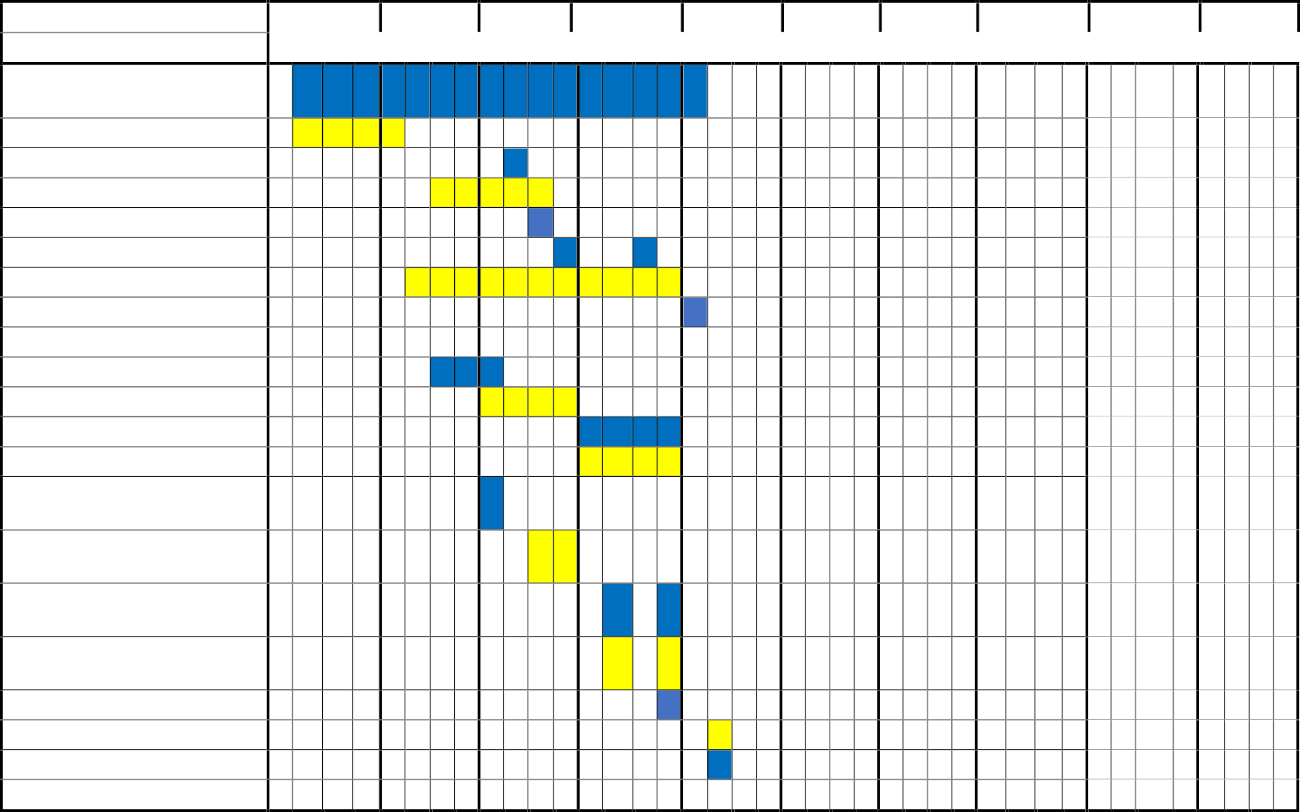MONTH ACTIVITY

Preparation for Capstone Project

Title Proposal Adviser approval Searching Client Approval of Client Interview with client Data Gathering Survey

+ Documentation Chapter 1

Chapter 2

Chapter 3

Chapter 4 Seeking guidance for chapter 1

Seeking guidance for chapter 2

Seeking guidance for chapter 3

Seeking guidance for chapter 4

Mock Defense Final Defense Re-defense

FEBRUARY MARCH APRIL MAY JUNE JULY AUGUST SEPTEMBER OCTOBER

+

NOVEMBE R

**Table 1 Gantt Chart**

### 24

*STI College San Jose Del Monte*

**Resources**

**Table 2 Hardware**

|  |  |
| --- | --- |
| Desktop | MSI |
| Laptop | Lenevo Legion 5 |
| Laptop | Lenovo |

**Table 3 Software**

|  |  |
| --- | --- |
| Operating System (OS) | Windows 11 Home 64-bit |
| Web Browser | Google Chrome |
| Visual Studio Code | Version 1.89.1 |
| MySQL | Version 8.4.0 |
| Figma | Version 9.0 |
| Draw.io | Version 24.4.8 |

## METHODOLOGY, RESULTS, AND DISCUSSION

The development process was neatly organized by the proponents using the software development life cycle (SDLC) method. The proponents followed the process of the Agile model since it allows for flexibility in responding to changing requirements and priorities, which is crucial in an information system where HR needs, and company operations can evolve over time. Agile aids in preparing for future developments by promoting flexibility and ongoing enhancements, empowering teams to efficiently adapt to shifting demands and provide value in a changing environment.

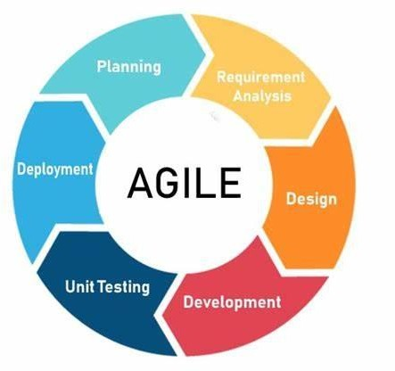

### Figure 1 Agile Methodology

**Requirements**

During this phase, the project team engaged in a frequent discussion with the human resource management to establish what the system needs to do. The information collected, along with insights from previous research, helped form an initial plan for the system’s potential features. As development progresses, these requiremnts are regularly reviewed and modified to make sure the Human Resource Information System adopts to changing user company needs.

### Design

During this phase, the project developed a web-based multi-platform system that aims to modernized HR processes at Gammacare Medical Services Inc. The system offers a user-friendly interface to make HR Processes more efficient for users while also providing tools to help the company employee management, time-in and time- out processes. The system incorporates various modules to help Admin to do administrative task, HR for employee management and Employee module to provide them interfaces for time-in and time-out.

### Development

This phase involves the system’s actual coding and programming, through which the team’s programming constructs the various components and features that will let all the company’s user access and manage their modules without any difficulties. The user interface is brought to life during this stage, ensuring that all users can quickly browse administrative tasks for Admin, Employee Management for HR, and Time-Management for Employees. The back-end functionality is being created at the same time to handle account details, user authentication, and data storage.

### Testing

In this phase, the system is ready for different testings, a crucial step to thoroughly investigate and determine wether it has met the desired output or not. This includes

evaluating the user-friendliness of the system, ensuring it functions correctly, and confirming that it aligns with the defined requirements. Alpha testing also plays a privotal role in identifying any issues or defects that may have slipped through the development phase, and addressing these promptly to enchance the system’s reliability and performance.

### Deployment

In during this phase, our client, Gammacare Medical Services Inc., can now use the system because the domain has already been registered and is supported by a web hosting service. This deployment stage is a crucial step where the team works diligently to make sure the system undergoes throrough testing, with a strong emphasis on ensuring that all modules are working correctly. If there are any potential issues, they are dealth with promtly to ensure a smooth experience for users.

### Review

Using assessment survey, the system is evaluated for performance at this phase. With the use of this survey, the team should be able to identify systematic flaws. The Human Resource Information System can be improved in numbers of ways, and this feedback-driven process is essential to determining which improvements and fixes should be given priority so that they better meet the client’s needs and expectations.

### Requirements Analysis

The proposed system for Gammacare Medical Services Inc. aims to provide a Human Resource Information System (HRIS) for the needs of the Human Resource Management (HRM) in the organization. The people involved include administrators, HR managers, and employees. Administrators will manage user accounts and roles, while HR managers will oversee recruitment, employee management, and payroll processes. Employees will interact with the system to view schedules, request leave, and access salary information. The system will cover business activities such as user account management, recruitment management, onboarding, employee information tracking, attendance monitoring, payroll processing, and reporting, all designed and centralized to enhance efficiency and accuracy.

The work environment includes both the physical locations of Gammacare Medical Services Inc. and remote access points, with the system being accessible online for flexibility and convenience. This ensures that users can perform necessary tasks from any location with internet access. Timing is crucial, as the system will provide continuous, real-time access for all users, supporting daily HR operations, periodic payroll processing, ongoing recruitment activities, and timely reporting. Automated features, such as recruitment updates and leave approval workflows, will ensure timely notifications and responses.

Current procedures will be significantly improved by the system's capabilities. User account management will be centralized, recruitment will utilize AI for resume matching, onboarding will be streamlined with automated updates, employee information will be maintained in a structured format, attendance will be tracked electronically, and payroll will be processed efficiently. Robust reporting features will offer insights into strategic decision-making. Overall, the proposed HRIS aims to provide a streamlined solution for Human Resource Management to meet the

organizational needs of Gammacare Medical Services Inc., ensuring enhanced efficiency, accuracy, and user satisfaction across all HR functions.

**Requirements Documentation**

**Super Admin Storyboard**

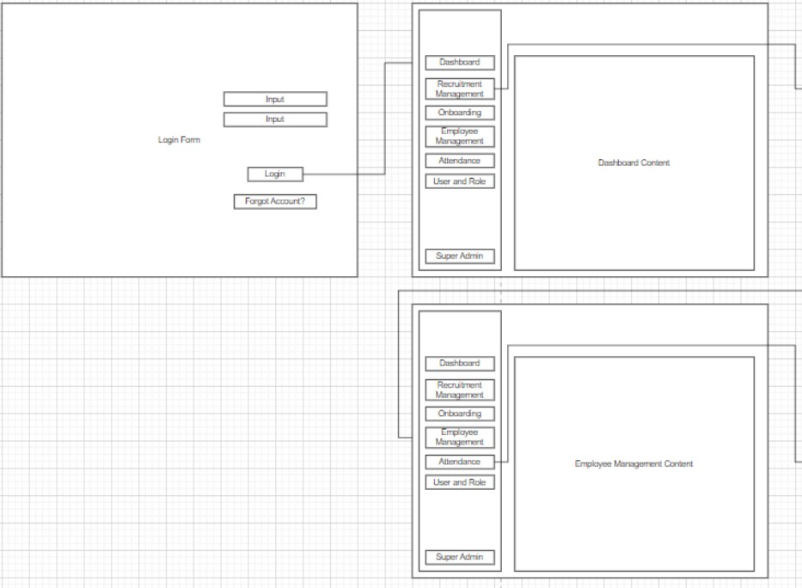

**Figure 2 Super Admin Storyboard**

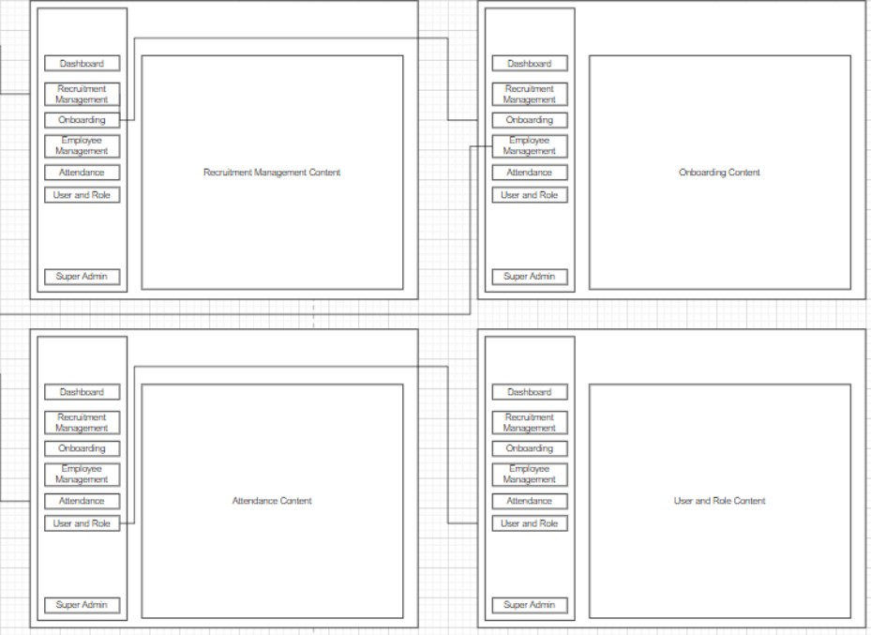

**Figure 3 Super Admin Storyboard**

**Human Resource Storyboard**

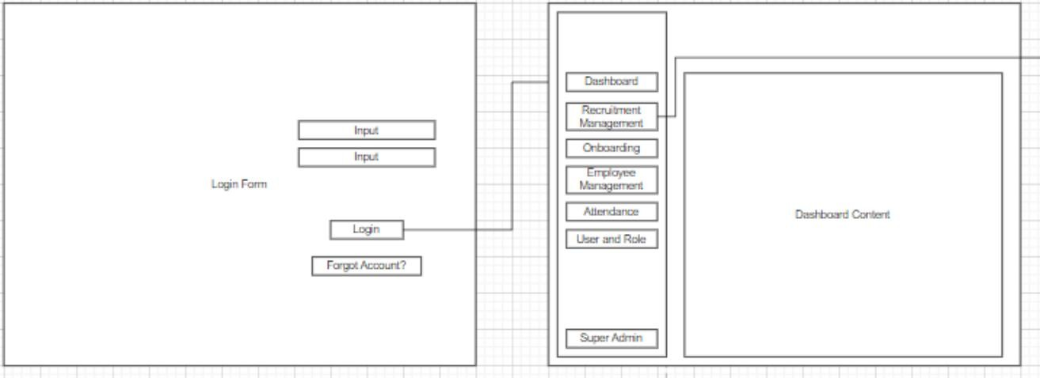

**Figure 4 Human Resource Storyboard**

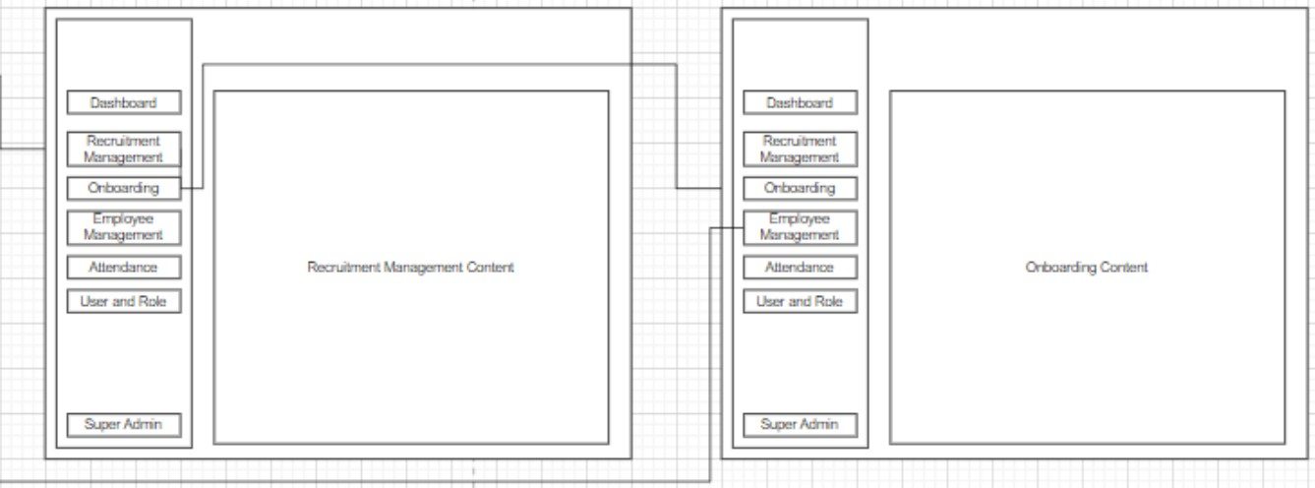

**Figure 5 Human Resource Storyboard**

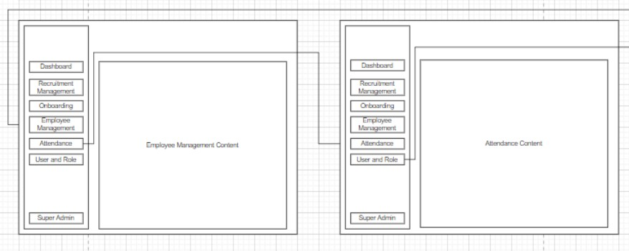

**Figure 6 Human Resource Storyboard**

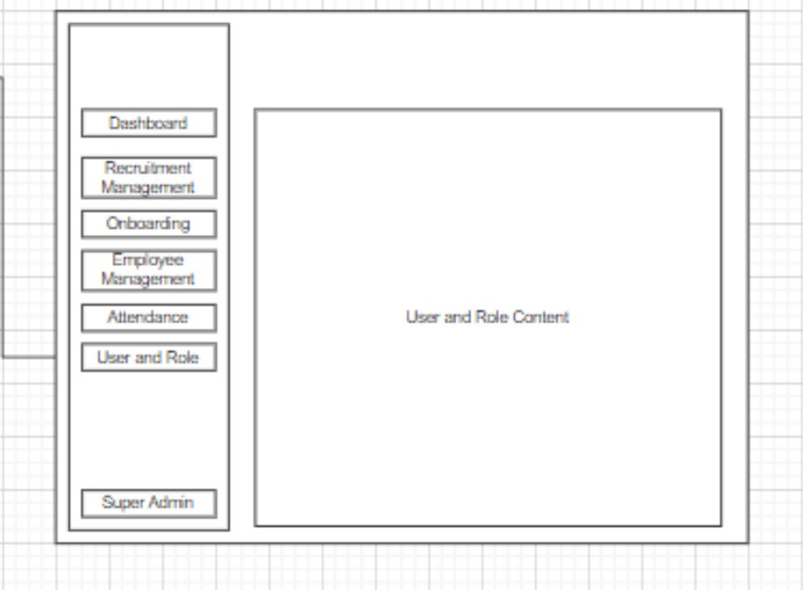

**Figure 7 Human Resource Storyboard**

**Employee Storyboard**

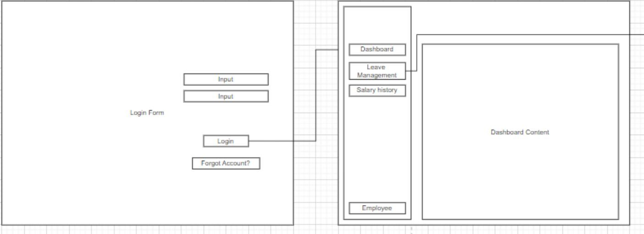

**Figure 8 Employee Storyboard**

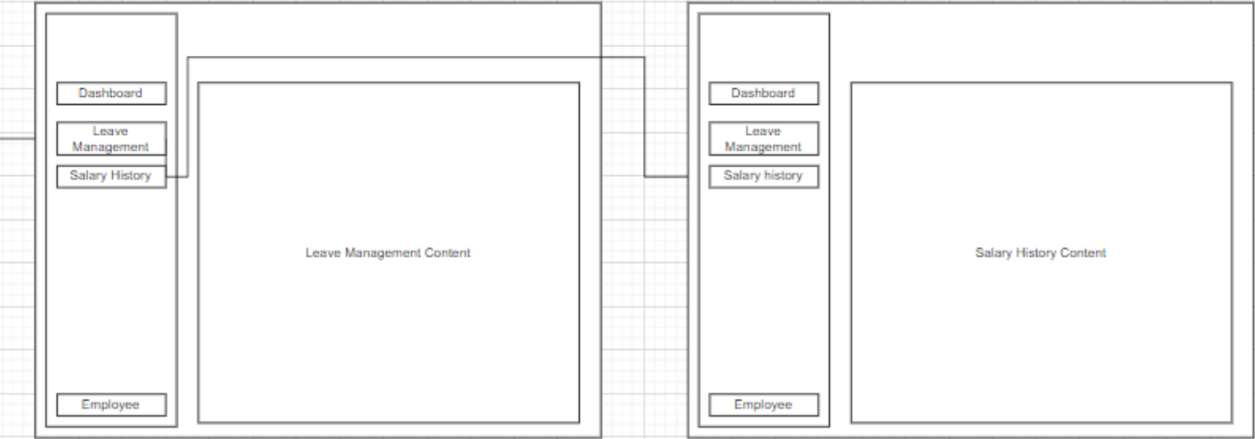

**Figure 9 Employee Storyboard**

**Design of Software, System, Product, and/or Processes**

This section showcases the system's user interface and design.

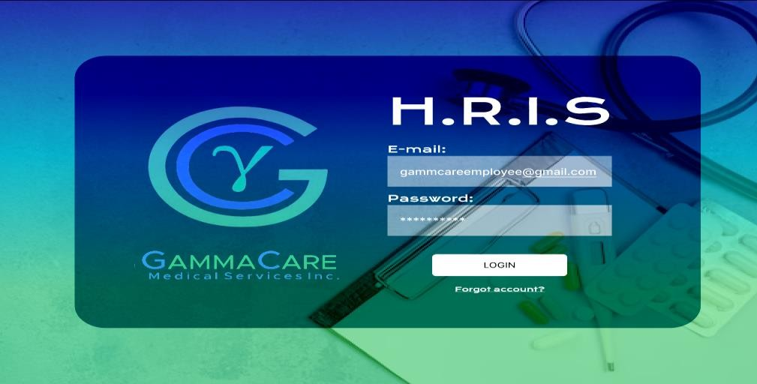

### Figure 10 Login Form

The preceding section highlights the log-in page of the website, where users can enter their credentials to redirect them to their respective module.

### Super Administrator Module

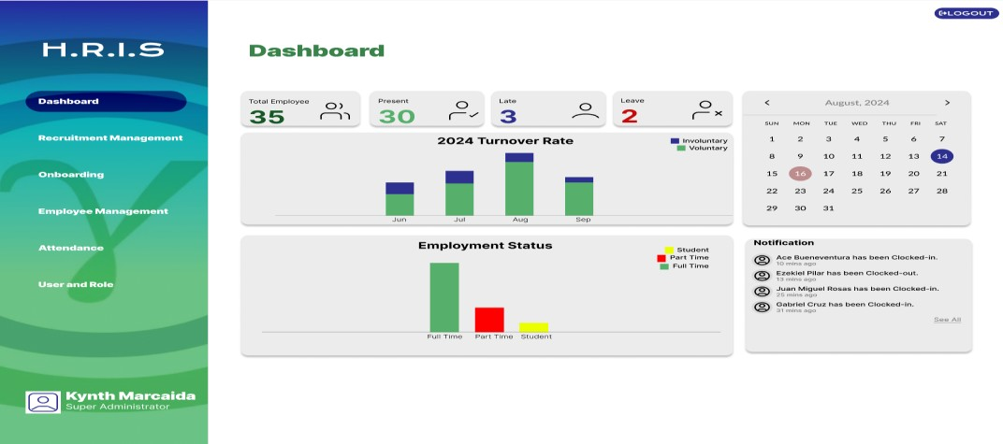

**Figure 11 Super Administrator Dashboard**

The Super Administrator Dashboard provides a comprehensive overview of system metrics, user activities, employee numbers, and administrative controls.

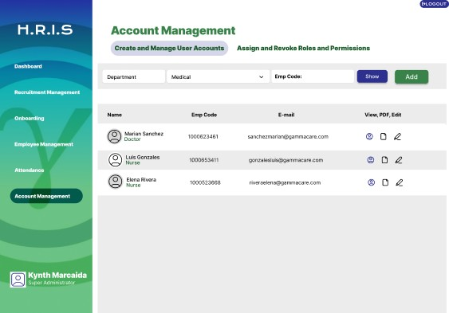

### Figure 12 Account Management

In this module, the Super administrator has the privilege to create and manage employee accounts. As well as assigning and revoking roles and permissions.

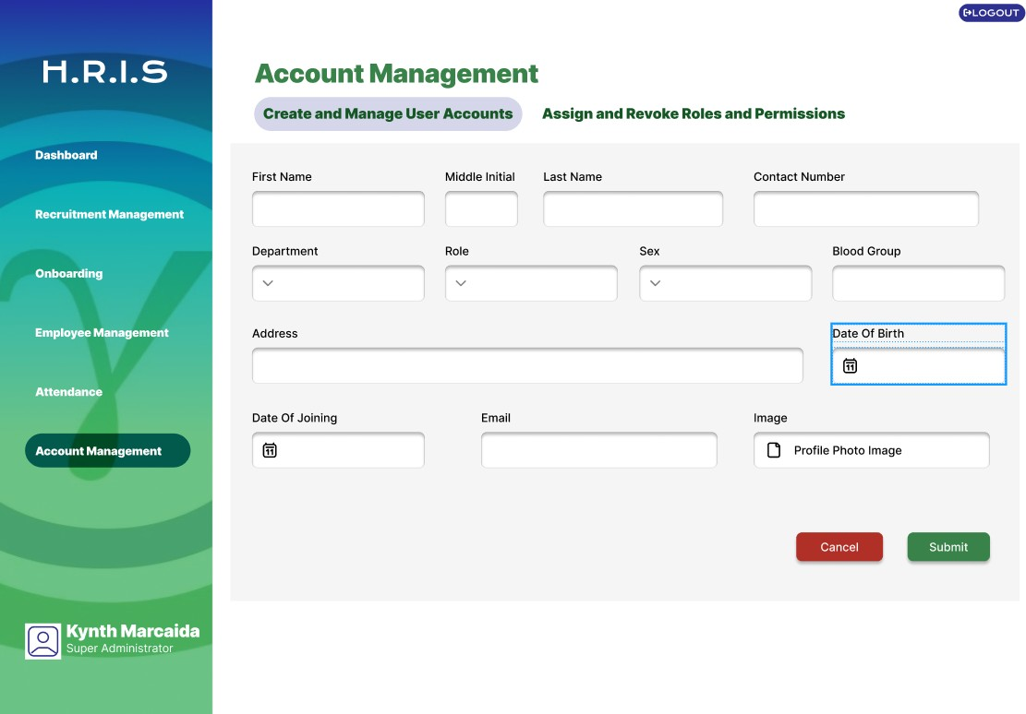

### Figure 13 Account Management: Add Accounts

The Account Management section allows for the creation of new accounts, specifically for administrative and HR roles. This feature ensures appropriate access and control for managing organizational resources and personnel.

### Human Resource Manager Module

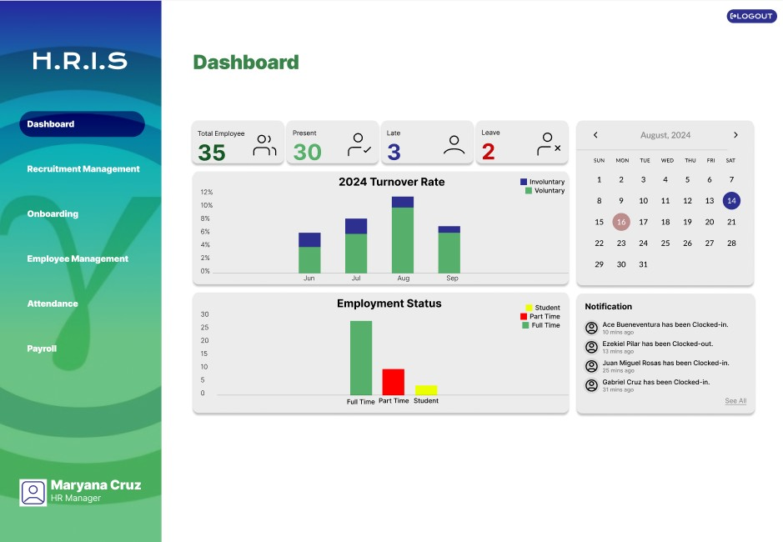

**Figure 14 Human Resource Manager Dashboard**

The Super Administrator Dashboard provides a comprehensive overview of system metrics, user activities, employee numbers, and administrative controls.

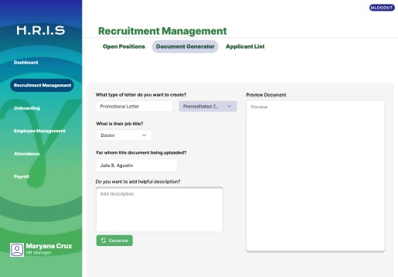

### Figure 15 Human Resource Manager Recruitment Management

The Recruitment Management module provides open positions, document generator, and applicant list.

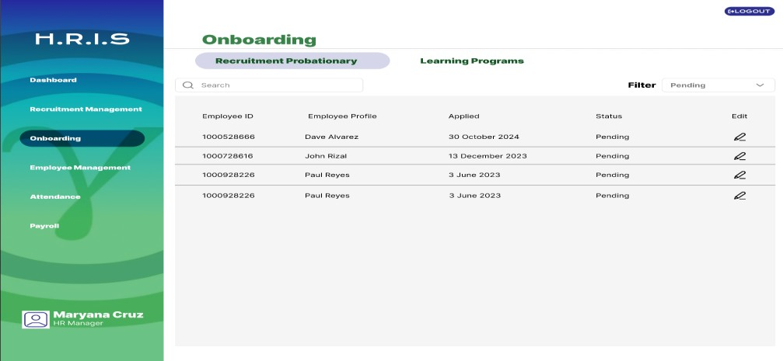

### Figure 16 Onboarding

The Onboarding module assists HR managers in integrating new hires into the company.

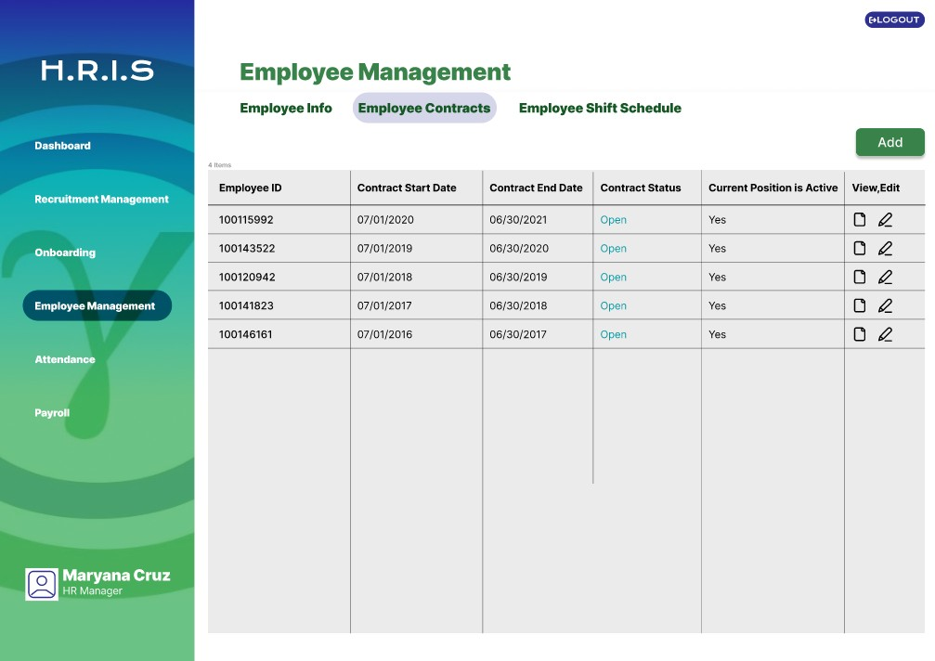

### Figure 17 Employee Management: Employee Contracts

This module focuses on managing employee contracts, including creation, modification, and tracking of contract terms.

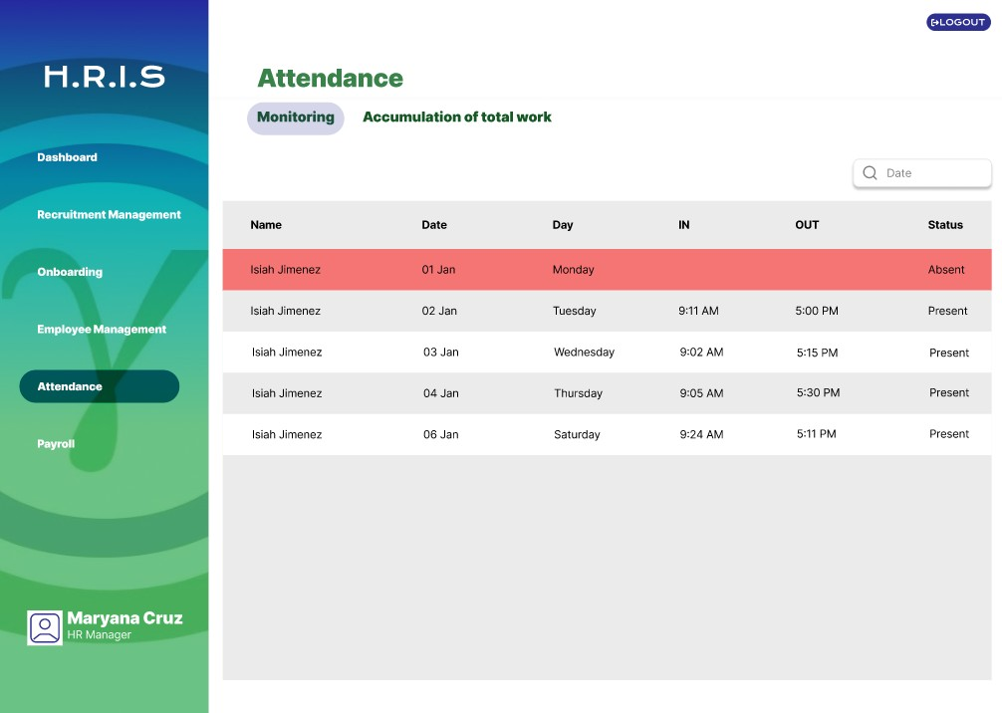

### Figure 18 Attendance

The Attendance module allows HR managers to monitor employee attendance and track working hours.

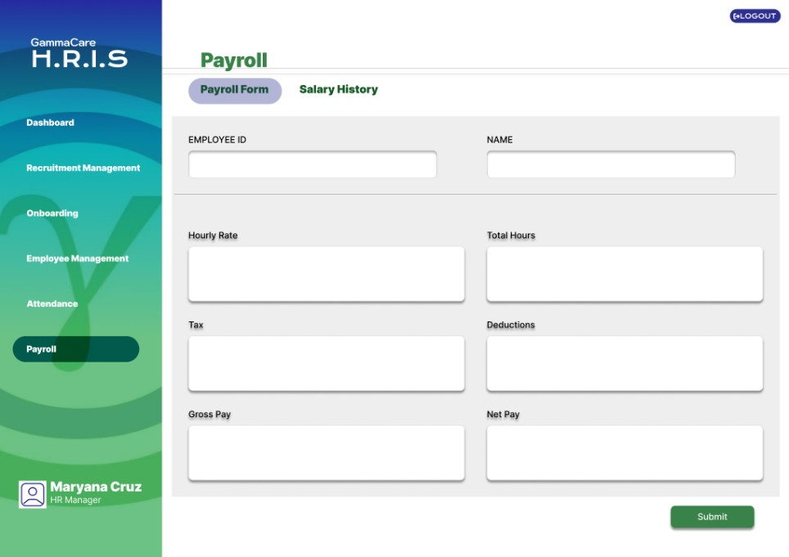

### Figure 19 Payroll

The payroll module computerizes the calculation and processing of employee salaries. It handles various payroll tasks such as salary computation, deductions, tax calculations, and generation of pay slips.

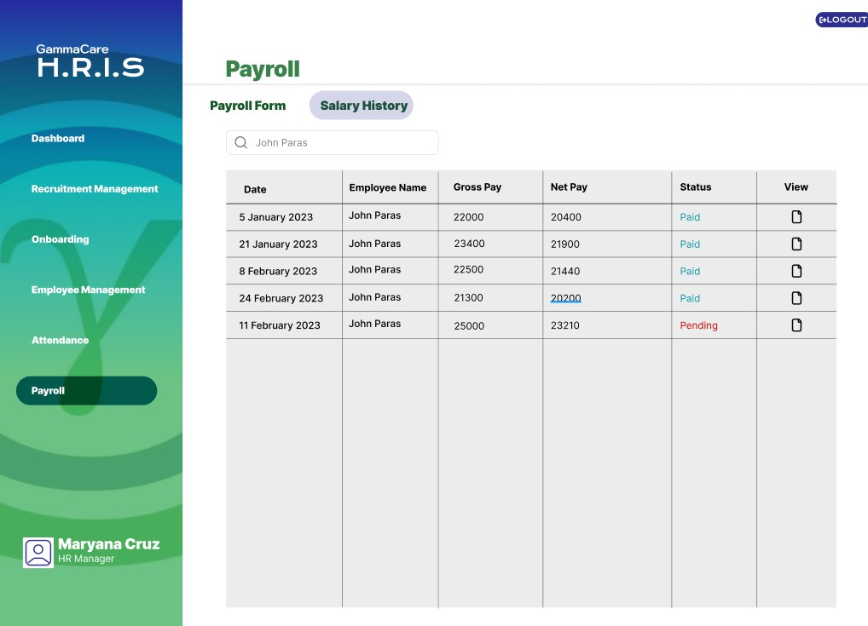

### Figure 20 Salary History

The Salary History section displays the past earnings and salary details of all employees within the organization.

### Employee Module

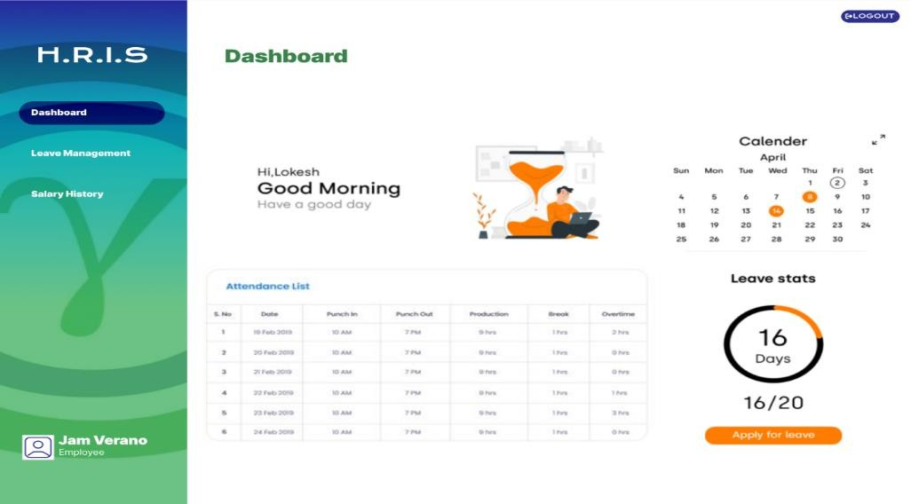

**Figure 21 Employee Dashboard**

The Employee Dashboard provides employees with access to their personal information, attendance records, leave balances, and other relevant data.

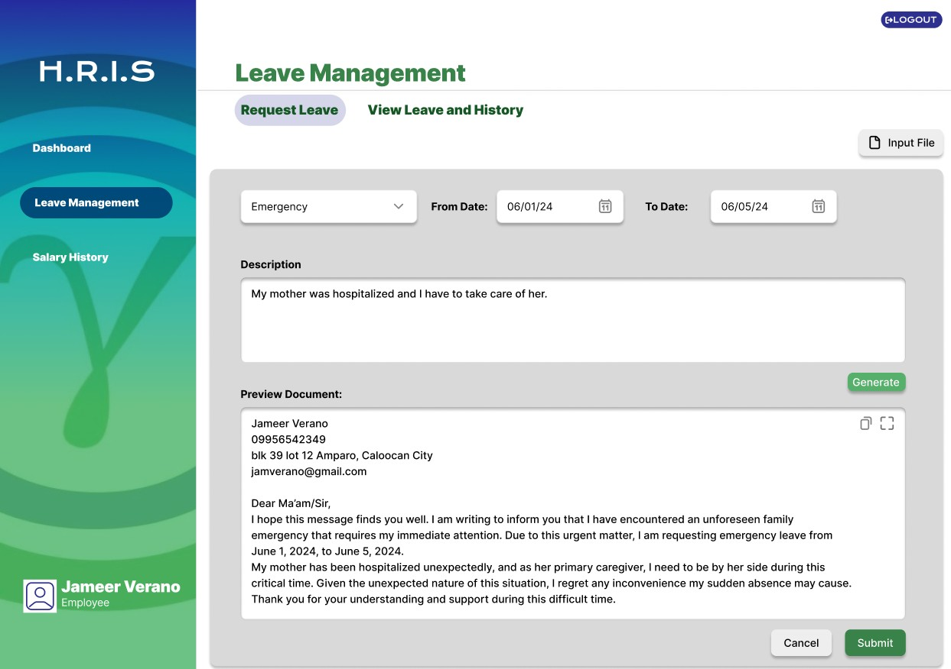

### Figure 22 Leave Management: Request and Track Leave

This module allows employees to request leave and track the status of their leave applications.

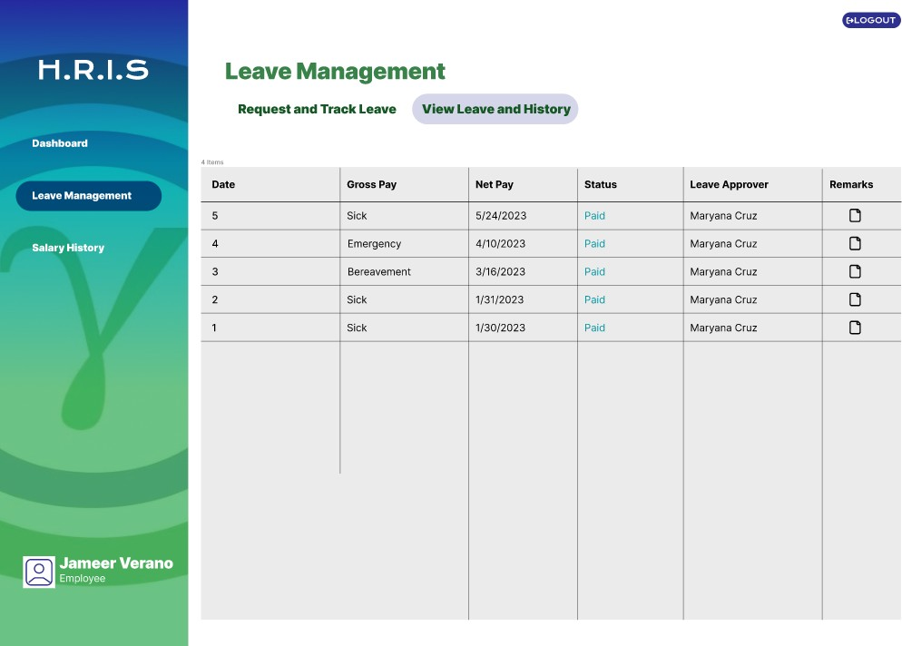

### Figure 23 Leave Management: View Leave and History

Employees can use this module to view their leave history and check the status of past leave applications.

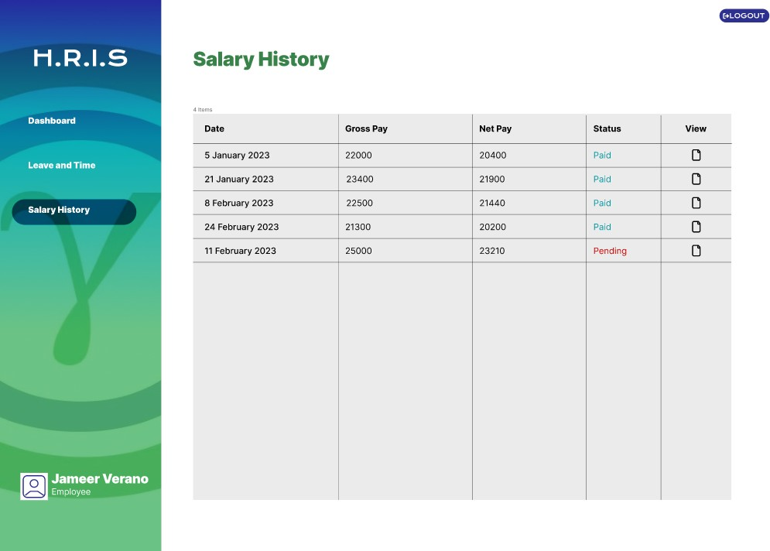

### Figure 24 Salary History

The Salary History module enables employees to view their salary records, including past pay slips and salary adjustments.

## REFERENCES

The reference list provides the information necessary for a reader to locate and retrieve any sources cited in the body of the paper. Each source you cite in the paper must appear in your reference list; likewise, each entry in the reference list must be cited in your text. Your references should begin on a new page separate from the text of the manuscript; label this page REFERENCES centered at the top of the page (bold, but do not underline or use quotation marks). All text should be double-spaced just like the rest of the text.

Balu, L. (2022). *Artificial Intelligence and Human Resource htt*[*ps://w*](http://www.researchgate.net/publication/357768551_Artificial_intelligence_and_human)*ww.re*[*searchgate.net/publication/357768551_Artificial_intelligence_and_human*](http://www.researchgate.net/publication/357768551_Artificial_intelligence_and_human)

*_resouce*

Panjaitan, E. (2023). Implementing Human Resource Information System (HRIS) for efficient human resource management. International Journal of Science and Society, 5(2), 128-139. *https://doi.org/10.54783/ijsoc.v5i2.676 htt*[*ps://w*](http://www.researchgate.net/publication/369965056_Implementing_Human_Resource_I)*ww.re*[*searchgate.net/publication/369965056_Implementing_Human_Resource_I*](http://www.researchgate.net/publication/369965056_Implementing_Human_Resource_I) *nformation_System_HRIS_for_Efficient_Human_Resource_Management*

Quaosar, G. M. A. A., & Rahman, M. S. (2021). Human Resource Information Systems (HRIS) of developing countries in the 21st century: Review and prospects. Journal of Human Resource and Sustainability Studies, 9(3), 470-483.

*https://doi.org/10.4236/jhrss.2021.93030 htt*[*ps://w*](http://www.scirp.org/journal/paperinformation?paperid=111944)*ww.sc*[*irp.org/journal/paperinformation?paperid=111944*](http://www.scirp.org/journal/paperinformation?paperid=111944)

Salah, H., Abdulgani, M. A., Aliuden, F., Mantikayan, J. M., Guiamalon, T., Dilna, S., Mohamad, H., & Ferolino, M. (2022). Adopting Human Resource Information System (HRIS)-Enabled Government Transformation: Perspective of MBHTE Employees. Psychology and Education: A Multidisciplinary Journal, 3(7), 1-7.

*https://doi.org/10.5281/zenodo.6983890 https://ejournals.ph/article.php?id=20441*

Salo, J., Fernando, F. D., Caparas, J., Lucido, K., Mapili, N., & Marasigan, K. C. (2023). Effectiveness on the implementation of Human Resource Information System to the user’s satisfaction at YNGEN Datacom Corporation [Bachelor's thesis, Polytechnic University of the Philippines]. *https://doi.org/10.13140/RG.2.2.19059.71202*

*htt*[*ps://w*](http://www.researchgate.net/publication/372511692_EFFECTIVENESS_ON_THE_IMP)*ww.re*[*searchgate.net/publication/372511692_EFFECTIVENESS_ON_THE_IMP*](http://www.researchgate.net/publication/372511692_EFFECTIVENESS_ON_THE_IMP) *LEMENTATION_OF_HUMAN_RESOURCE_INFORMATION_SYSTEM_TO_THE_USE R'S_SATISFACTION_AT_YNGEN_DATACOM_CORPORATION*

Udekwe, E., Iwu, C., De La Harpe, A., & Daramola, O. (2022). Effective utilization of human resource information systems in the South African health sector (Awarded the best poster presented at the conference). *https://doi.org/10.13140/RG.2.2.19852.53120*

*htt*[*ps://w*](http://www.researchgate.net/publication/358816600_Effective_Utilisation_of_Human_R)*ww.re*[*searchgate.net/publication/358816600_Effective_Utilisation_of_Human_R*](http://www.researchgate.net/publication/358816600_Effective_Utilisation_of_Human_R) *esource_Information_Systems_in_the_South_African_Health_Sector_Awarded_the_best*

*_poster_presented*

## APPENDICES

**APPENDIX A. RESOURCE PERSONS**

### Silmaro, John Carlo D.

Capstone Project Adviser

STI College San Jose Del Monte

### Lintag, Norvin Shaq F.

Capstone Panelist

STI College San Jose Del Monte

### Gardner, Herbert G.

Capstone Panelist

STI College San Jose Del Monte

### Barrameda, Chris Jonel B.

Capstone Coordinator

STI College San Jose Del Monte

### Isip, Jayne F.

Capstone Coordinator

STI College San Jose Del Monte

## APPENDIX B. PERSONAL TECHNICAL VITAE

Curriculum Vitae of

# KYNTH ANTHONY P. MARCAIDA

**Blk 210 Lot 4 Area D Sta. Cruz V, San Jose Del Monte, Bulacan** [**Kynth65@gmail.com**](mailto:Kynth65@gmail.com)

**+63 961 286 3209**

EDUCATIONAL BACKGROUND

|  |  |  |
| --- | --- | --- |
| Level | Inclusive Dates | Name of school/ Institution |
| Tertiary | July 2021 - Present | STI College San Jose Del Monte |
| Vocational/Technical | N/A | N/A |
| High School | June 2014 - 2018 | Sapang Palay National High School |
| Elementary | June 2008 - 2014 | BBC Elementary School |

PROFESSIONAL OR VOLUNTEER EXPERIENCE

|  |  |  |
| --- | --- | --- |
| Inclusive Dates | Nature of Experience/  Job Title | Name and Address of Company or  Organization |

AFFILIATIONS

|  |  |  |
| --- | --- | --- |
| Inclusive Dates | Name of Organization | Position |
| July 2014 – June 2016 | Special Program in the Arts (SPA) | Singer |

SKILLS

|  |  |  |
| --- | --- | --- |
| SKILLS | Level of Competency | Date Acquired |
| HTML | Intermediate | December 2023 |
| Python | Novice | Feb 2022 |
| C# | Intermediate | March 2023 |
| Java CSS  JavaScript | Intermediate Intermediate  Intermediate | July 2021  December 2023  February 2024 |

TRAININGS, SEMINARS, OR WORKSHOPS ATTENDED

|  |  |
| --- | --- |
| Inclusive Dates | Title of Training, Seminar, or Workshop |
| March 2023 | SAP Business One |

Curriculum Vitae of

# EZEKIEL B. PILAR

**60 Aguila Street, Barangay 182 Caloocan City** [**ezekielpilar27@gmail.com**](mailto:ezekielpilar27@gmail.com)

**+63 999 411 1811**

EDUCATIONAL BACKGROUND

|  |  |  |
| --- | --- | --- |
| Level | Inclusive Dates | Name of school/ Institution |
| Tertiary | July 2021 - Present | STI College San Jose Del Monte |
| Vocational/Technical | N/A | N/A |
| High School | June 2014 - 2019 | Pangarap High School |
| Elementary | June 2009 - 2014 | Pangarap Elementary School |

PROFESSIONAL OR VOLUNTEER EXPERIENCE

|  |  |  |
| --- | --- | --- |
| Inclusive Dates | Nature of Experience/  Job Title | Name and Address of Company or  Organization |

AFFILIATIONS

|  |  |  |
| --- | --- | --- |
| Inclusive Dates | Name of Organization | Position |
| N/A | N/A | N/A |

SKILLS

|  |  |  |
| --- | --- | --- |
| SKILLS | Level of Competency | Date Acquired |
| HTML | Novice | April 2023 |
| SAP Business One | Intermediate | Septermber 2023 |
| Python | Intermediate | March 2023 |
| C# | Intermediate | March 2023 |
| Java | Intermediate | July 2021 |

TRAININGS, SEMINARS, OR WORKSHOPS ATTENDED

|  |  |
| --- | --- |
| Inclusive Dates | Title of Training, Seminar, or Workshop |
| March 2023 | SAP Business One |

Curriculum Vitae of

# JUAN MIGUEL A. ROSAS

**653 Makabud Street, Barangay 179 Caloocan City** [**rosasjuanmiguel0@gmail.com**](mailto:rosasjuanmiguel0@gmail.com)

**+63 968 764 8912**

EDUCATIONAL BACKGROUND

|  |  |  |
| --- | --- | --- |
| Level | Inclusive Dates | Name of school/ Institution |
| Tertiary | July 2020 - Present | STI College San Jose Del Monte |
| High School | June 2014 - 2020 | Amparo High School |
| Elementary | June 2008 - 2014 | Amparo Elementary School |

PROFESSIONAL OR VOLUNTEER EXPERIENCE

|  |  |  |
| --- | --- | --- |
| Inclusive Dates | Nature of Experience/  Job Title | Name and Address of Company or  Organization |
| February 2020 - Present | Photographer / Graphic Designer | Obra ni Juan |

AFFILIATIONS

|  |  |  |
| --- | --- | --- |
| Inclusive Dates | Name of Organization | Position |
| March 2017 -  2018 | Amparo Integrity Leaders | Grade 9 Representative |

SKILLS

|  |  |  |
| --- | --- | --- |
| SKILLS  PHP | Level of Competency  Novice | Date Acquired  April 2024 |
| HTML | Novice | April 2024 |
| SAP Business One | Intermediate | Septermber 2023 |
| Python | Intermediate | March 2023 |
| C# | Intermediate | March 2023 |
| Java | Intermediate | July 2020 |

TRAININGS, SEMINARS, OR WORKSHOPS ATTENDED

|  |  |
| --- | --- |
| Inclusive Dates | Title of Training, Seminar, or Workshop |
| March 2023 | SAP Business One |

Curriculum Vitae of

# JAMEER KEN S. VERANO

**Blk41 lot20 Dao st. corner Katuray, Barangay 179 Caloocan City** [**jameerkenverano@gmail.com**](mailto:jameerkenverano@gmail.com)

**+63 995 825 2189**

EDUCATIONAL BACKGROUND

|  |  |  |
| --- | --- | --- |
| Level | Inclusive Dates | Name of school/ Institution |
| Tertiary | July 2020 - Present | STI College San Jose Del Monte |
| Vocational/Technical | N/A | N/A |
| High School | June 2014 - 2020 | Amparo High School |
| Elementary | June 2007 - 2014 | Amparo Elementary School |

PROFESSIONAL OR VOLUNTEER EXPERIENCE

|  |  |  |
| --- | --- | --- |
| Inclusive Dates | Nature of Experience/  Job Title | Name and Address of Company or  Organization |
| December 2023 | Relief goods packing | DSWD Pasay City |

AFFILIATIONS

|  |  |  |
| --- | --- | --- |
| Inclusive Dates | Name of Organization | Position |
| June 2024 | MCGI | Production Team |

SKILLS

|  |  |  |
| --- | --- | --- |
| SKILLS | Level of Competency | Date Acquired |
| HTML | Novice | April 2024 |
| SAP Business One | Intermediate | Septermber 2023 |
| Python | Intermediate | March 2023 |
| C# | Intermediate | March 2023 |
| Java | Intermediate | July 2020 |

TRAININGS, SEMINARS, OR WORKSHOPS ATTENDED

|  |  |
| --- | --- |
| Inclusive Dates | Title of Training, Seminar, or Workshop |
| March 2023 | SAP Business One |